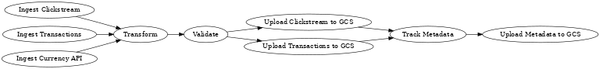

Figure 1 :Architectural Flow Diagram

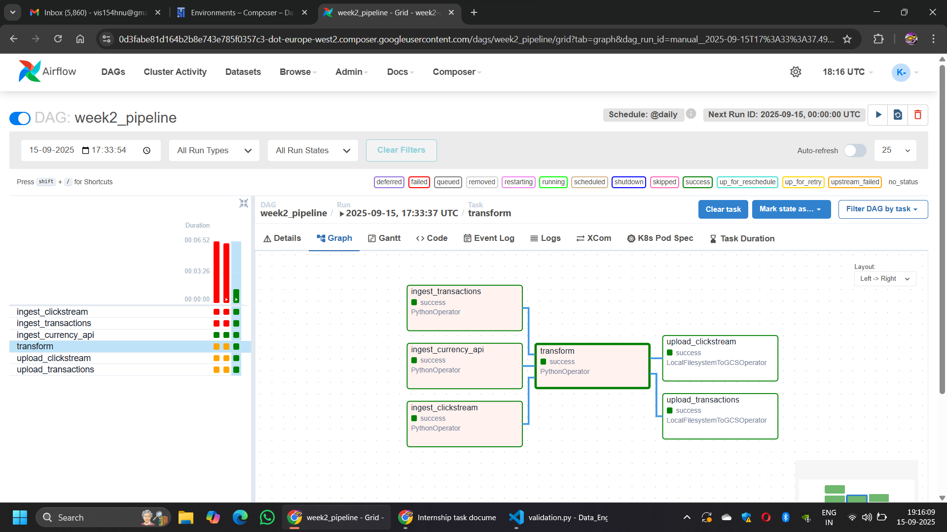

Figure 2 : Pipeline before validation

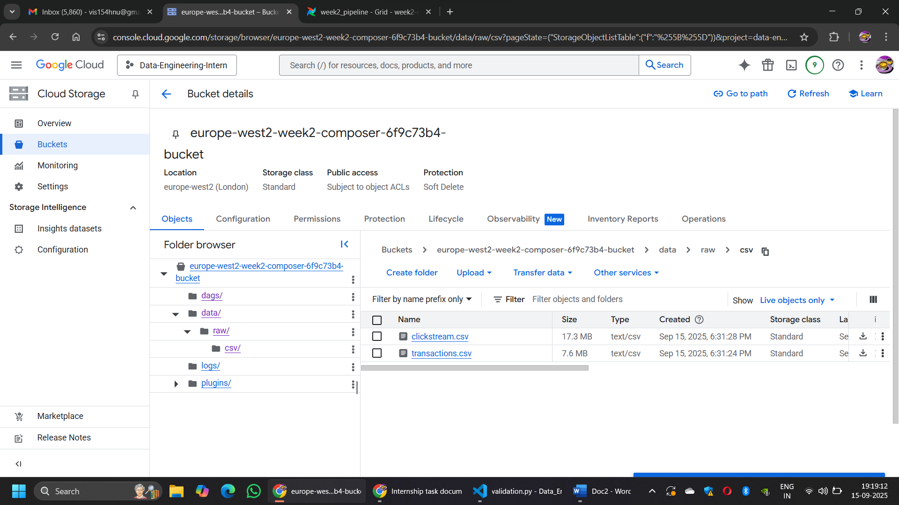

Figure 3 : Storage bucket

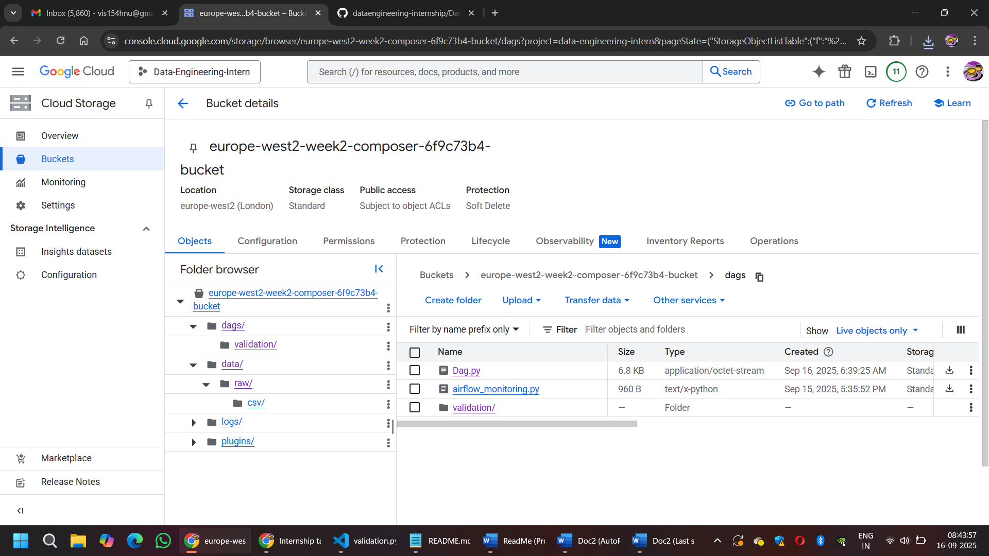

Figure 4: storage of dag and validation file.

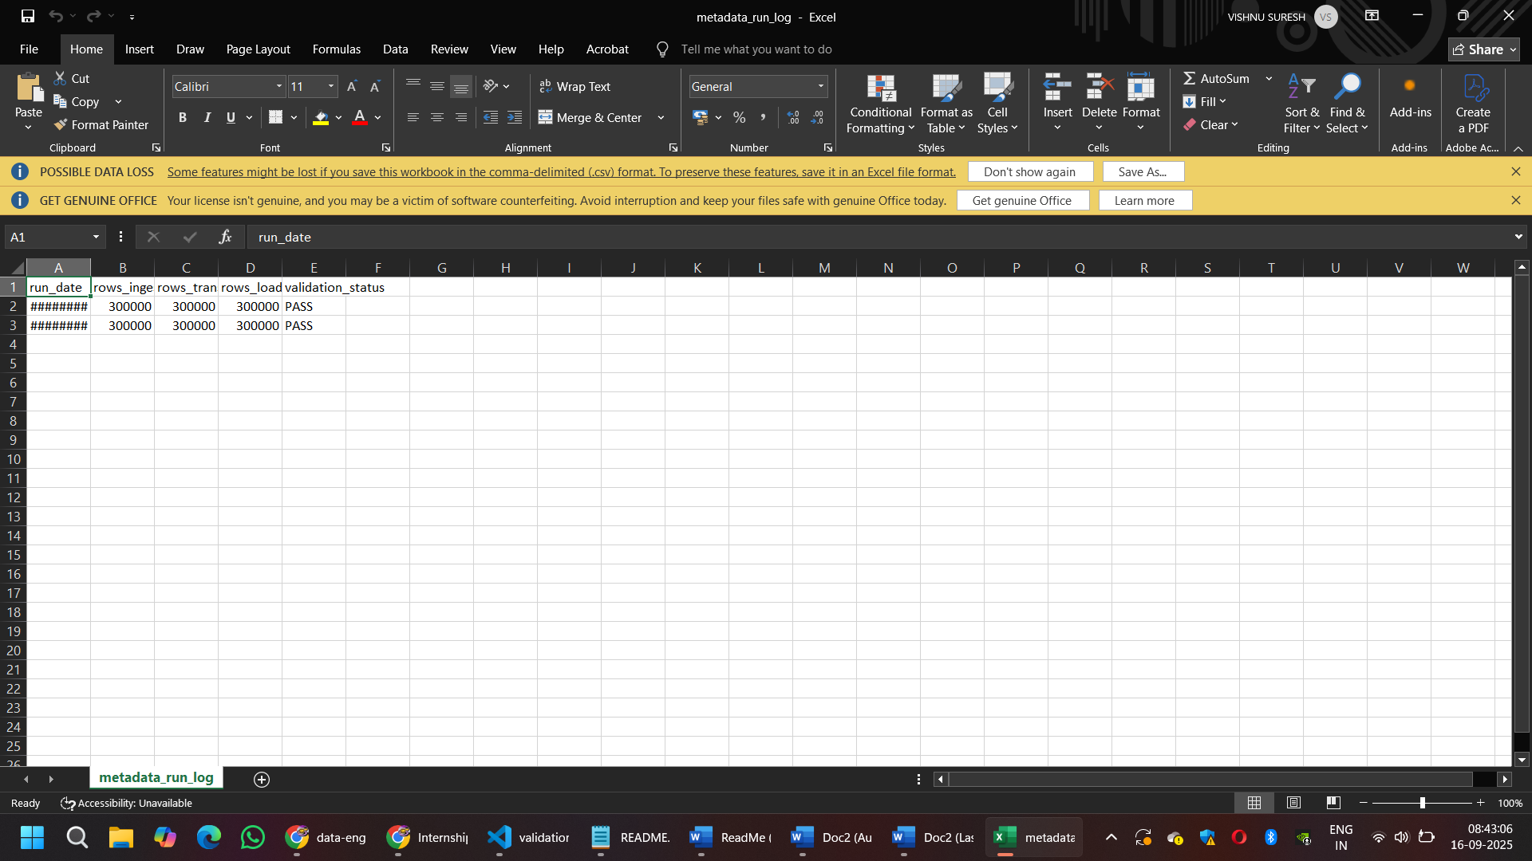

Figure 5: Contents generated by meta data.

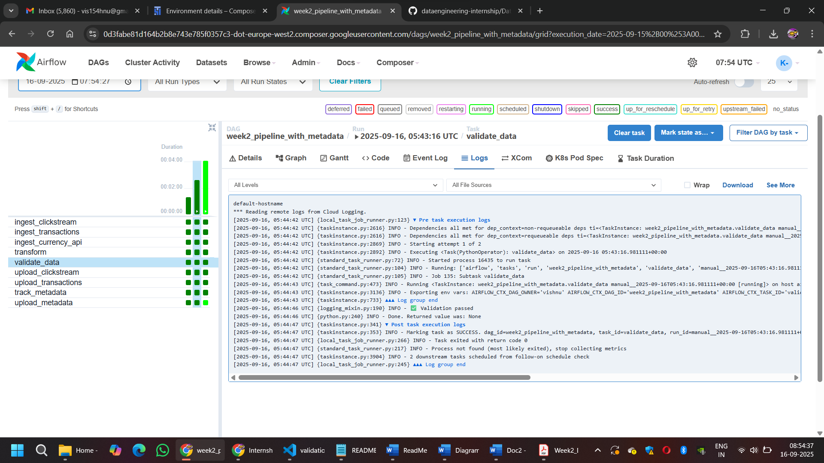

Figure 6:Log for validation of the data.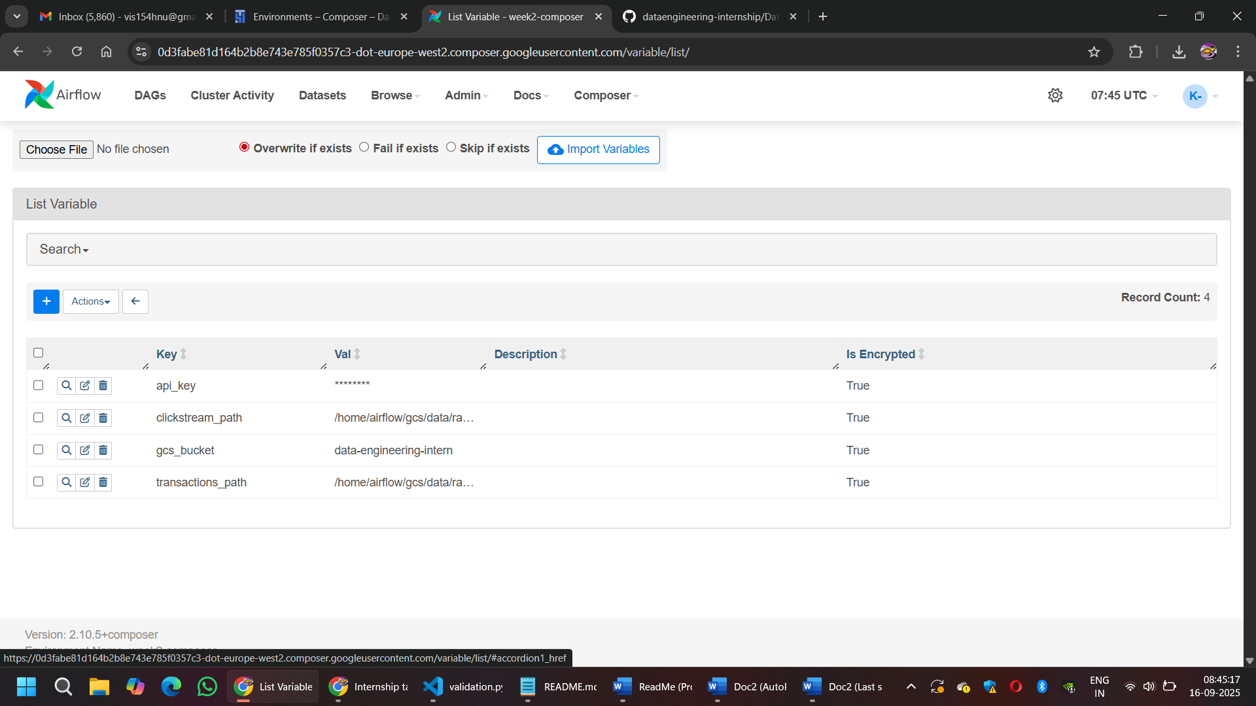

Figure 7: storage of values inside airflow.

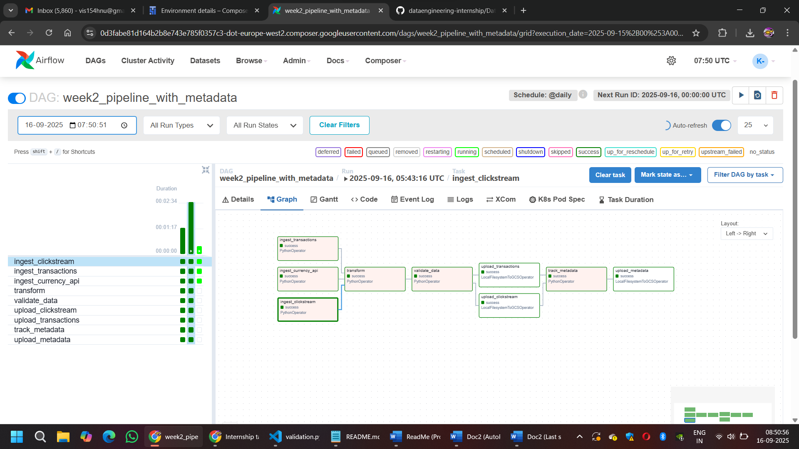

Figure 8 : Manually Triggering the DAG

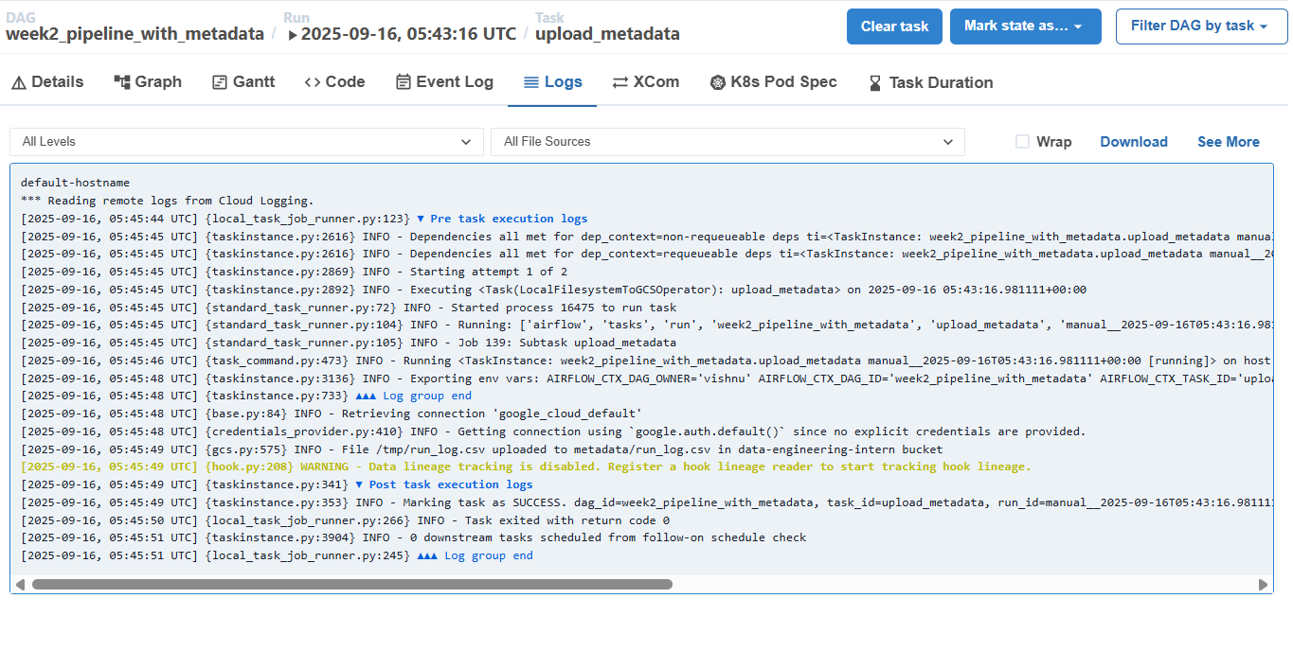

Figure 9: Final Logs